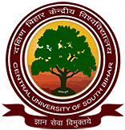

CENTRAL UNIVERSITY OF SOUTH BIHAR

SCHOOL OF LAW & GOVERNANCE

**THE STATUS OF WOMEN IN QURAN AND HADITH**

A

* SUBMITTED TO:
* Mr. Anil Kumar

(Assistant Professor,

Central University of South Bihar)

* SUBMITTED BY:
* Aneesh raj
* 2nd semester
* Enrolment no. CUSB1913125020